Oceania-Indo-Sulawesi-Toraja-Water Buffalo Sacrifice Sculpture-Limestone-ca 1700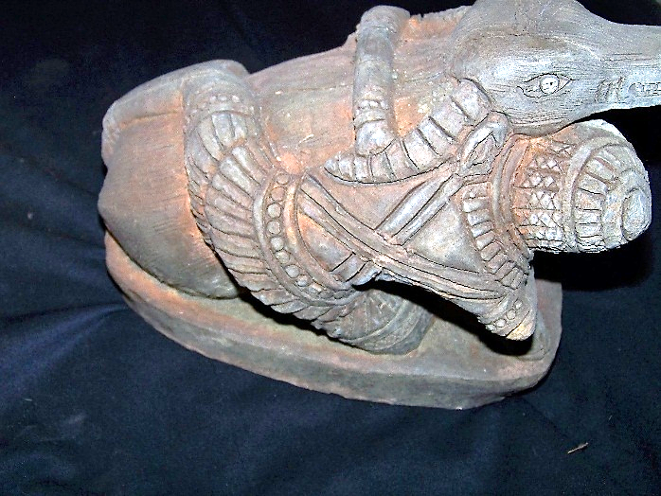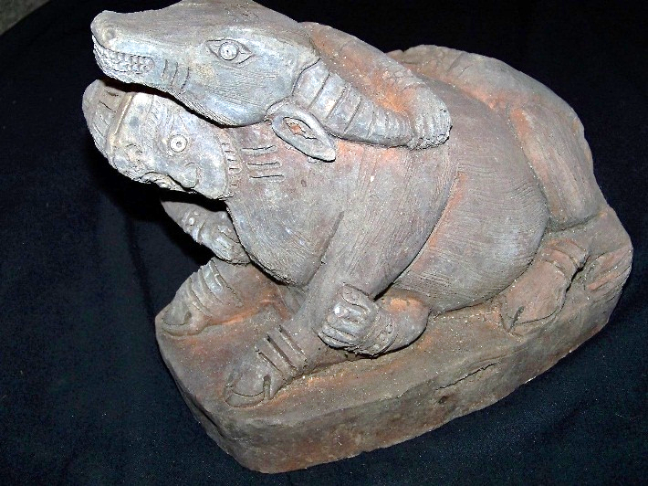

Figs. 1-2. Sulawesi-Toraja-Water Buffalo Sacrifice Sculpture-Limestone-ca 1700

**Case no.: Oceania**

**Accession Number: A000**

**Formal Label:** Sulawesi-Toraja-Water Buffalo Sacrifice Sculpture-Limestone-ca 1700

The sacrifice of water buffalos or ***Ma’patinggorok Tedong*** is a central event held at the decease of an elder. The most valued water buffalo is the black and white or Tedong Tedong bonga.because of its combination of two colors, like the heron.Torajans believe thatthe spirit needed water buffalo in order for them to arrive at *puya (*making a spiritual connection with the divine)fasterwhen more water buffalos are sacrificed. The afterworld is Puya, "the land of souls," which is to the southwest under the earth. By a lavish death feast the deceased will reach Puya. He is judged by Pong Lalondong and then climbs a mountain to reach heaven, where he joins the deified ancestors as a constellation which guards mankind and the rice. *Rambu Solo* will be more festivewhen the deceased is a descendant of a king or a wealthy person; thisappears from the amount of sacrificed water buffalo and pigs, this will be a measurement of their wealth and rank when they were still alive. Building tomb for family members that have passed away and having *Rambu Solo*’ ceremony usually needs hundreds of million up to billions of Rupiah. No less than 150 animals are needed for the sacrifice, which consists of water buffalos and pigs. Family members will share water buffalo and pigs meat to neighbors who have helped them with the *Rambu Solo*’ ceremony.

.

Fig. 5. Tedong Tedong Bonga or black and white water buffalo that has an important role in *Ma’patinggorok Tedong* and is a symbol of prestige in Torajan society. Photo : Aris Setiawan

*Ma’patinggorok Tedong* is a ceremony where water buffalos are sacrificed using *parang* or long machete in one cut. *Tedong*, is the Toraja name for water buffalos, *Bubalus bubalis*, which is the only species available. There are two kinds of *tedong*, a black *tedong* and *tedong tedong bonga,* black and white. The price of a black *tedong* is around 10-25 million rupiahs, and that of a *tedong tedong bonga* is perhaps ten times as much. Purportedly, once someone tried to take a *tedong tedong bonga* out of Tana Toraja, but it was found that this species cannot survive out of the Toraja domain, due to exhaustion or a difference in temperature. Some also believe it was due to mythical reasons. For Torajans who can afford to have a ceremony by sacrificing a *tedong tedong bonga*, this will increase the level of prestige in the society.

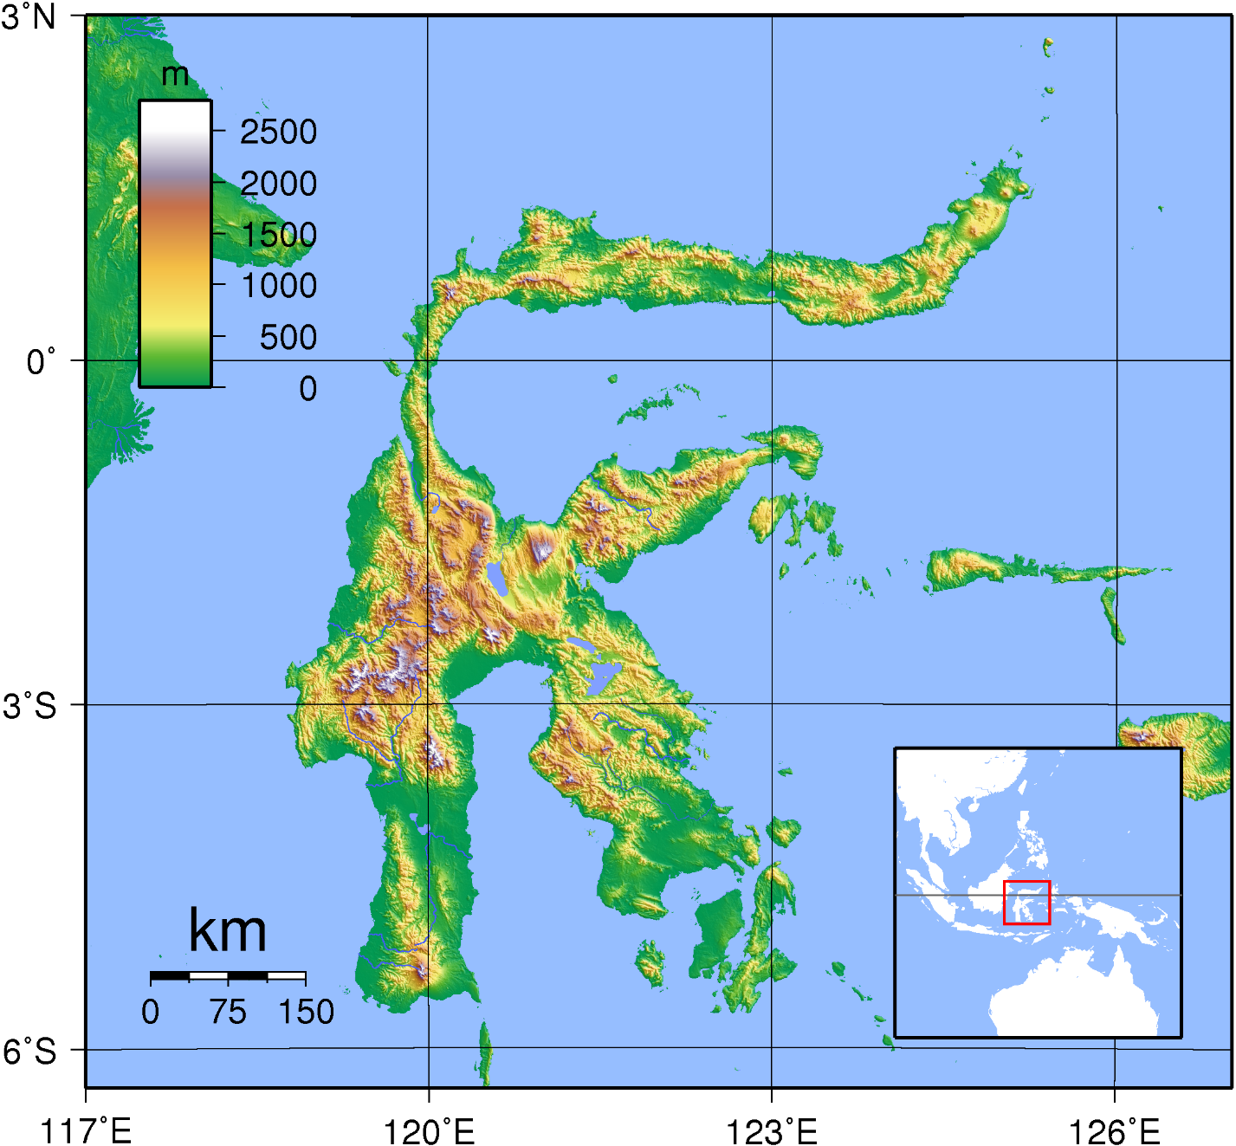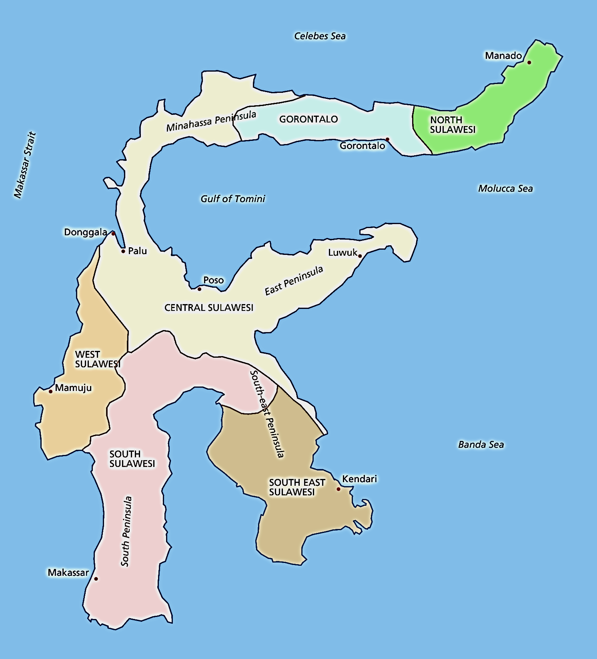

Figs. 3-4. Maps of Sulawesi in Indonesia

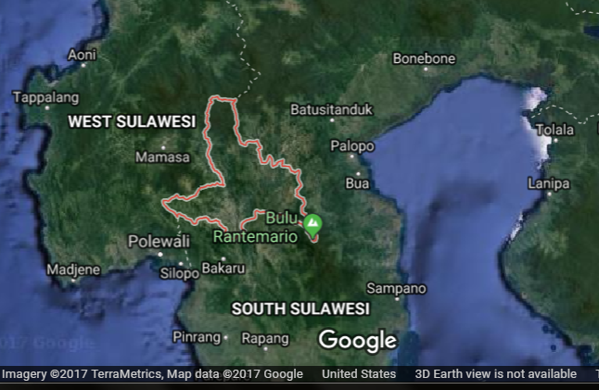

**Map. 5. South Sulawesi showing Rantemario**

**GPS: -3°22'54.00" S 120°01'43.00" E**

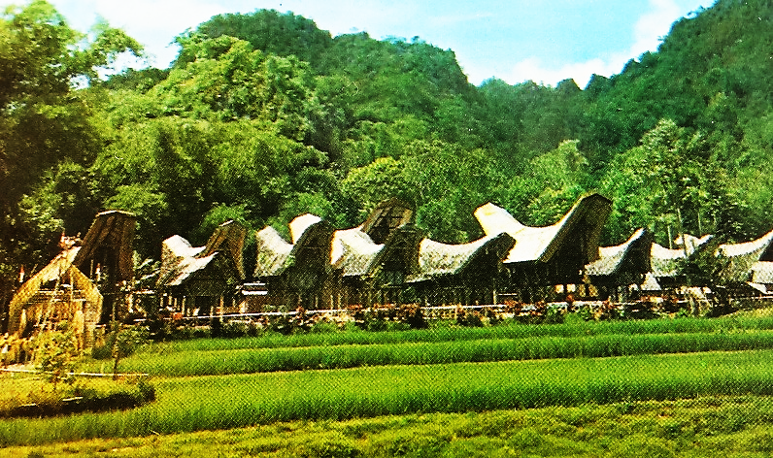

Fig. 6. Sa'dan-Toraja village of Ke Te in South Sulawesi in a post card ca. 1950 showing the inland mountainous landscape in the background and wet-rice patties in the foreground. After <http://www.bendav.nl/gif/ebay/1425.jpg>.

*Tongkonans* are shaped like boats and all face north, symbolizing the legend of the origin of the Torajans as coming by sea from Taiwan. The word “*tongkonan*” derives from Torajan language *tongkon* (sit, stay, reside), so the *Tongkonan* is where the center of social life for Torajans resides.

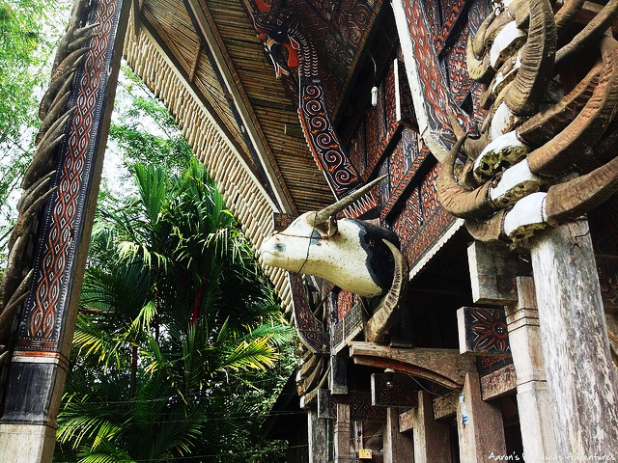

Fig. 7, Water buffalo horns and a carved water buffalo head adorn the exterior of a *tongkonan* in the village of Kete Kesu as an acknowledgement of the primal lace the water buffalo holds in the religion the Toraja.

Although *tongkonans* are family houses, the family does not usually live in them. Instead, they serve a ceremonial role and are used to store the embalmed corpse while the family has a chance to save up enough money for the funeral, costing thousands, or even tens of thousands of U.S. dollars. That process can take months, or even years! Extravagant funerals are what the Torajan people are really famed for, enormous events where the entire extended family and town show up to pay their respects and present offerings for sacrifice.

When a person dies Galumpang cloth, which has reddish hue combined with yellow and blue and is used, to cover the coffin. It shows two-directional arrow heads, symbolizing the dynamics of life. The house of the deceased, meanwhile, is circled by a long strip of this red cloth (Kartiwa, 2007). Then the ritual of *pallulukan* or the blackening of clothes is done by the immediate family of the dead. The family would go to a prepared open space outside the village, or sometimes this might also take place at the space below the family’s stilted house. A hole containing a mixture of water, soil, leaves of *bilante* shrubs and sweet potato has been prepared for the family, who would then dip their clothes there. A pig is sacrificed during the ritual and one of its ears is left in a bamboo hollow near the hole. Members of the family who are unable to come to the ritual could then come to the place, dip their finger in the hole and leave a black mark on the pig’s ear. The family should refrain from eating rice and only wear black until the seventh day after the burial, on which day the family visit the grave again for the first time. As they

go back home, they would eat rice again and discard their black clothes. Their refraining from eating rice shows their solidarity with the dead, who would no longer eat rice.

The Toraja, who live in Central and South Sulawesi, formerly known as the Celebes, speak an Austronesian, Malayo-Polynesian language and have an animist religion (Gordon 2005: 434). Their neighbors, the Bugis, are also an Austronesian-speaking people with an animist religion, Tolotang. Both groups had migrated to south Sulawesi around 2500 BCE from Taiwan after first emigrating from south China (Wen and Chen 2008). Thus, they were part of the Austronesian expansion that ultimately led to the Polynesian migrations into the Pacific islands. The Bugis call the Sa'dan-Toraja, To-ri-aja (To-ri-adja) that literally means “people from the interior” where there are many mountains up to 3,000 m high. So the Toraja are also considered mountain people. When the English arrived, they thought the Toraja’s name denoted a place “To” Raja”, but in Indonesian “raja” means "king" or "ruler,” so when the British referred to these people as people of raja they were in a sense called "people of high rank." To the Toraja, themselves, “raja” means “magnificent” or “handsome”. Thus, these three meanings of “Toraja” coalesce in referring to these people as “handsome people of high rank from the mountains”.

Although recent demographic figures are not available we do have the following statistics. There were about 325,000 Torajans (Nooy-Palm in Eliade 1987, Vol. 14, 565). In 1975 half of these practised Aluk To Dolo. Now this is estimated to be only 30 per cent. Of the remainder 60 per cent are Christian and 10 per cent Muslim (Dalton 1988, 845).

When a noble dies, a stone pillar or a sculpted representation of the Water Buffalo Sacrificial Ceremony, like the one pictured above, would be erected. Under the pillar or the sculpture, a piece of iron and yellow beads, *manik riri*, are placed, symbolizing strength and wealth, in the hope that the family of the dead would be strong and prosper.

**Date or Time Horizon:** ca 1700

**Geographical Area:** South Sulawesi

**Cultural Affiliation:** Sa'dan-Toraja

**Medium:** limestone

**Dimensions:** L 9 in

**Weight:**

**Provenance:** The Bouck Estate, New York City, 1950-2013, then Ballston Spa, New York.

**References**

Adams, Kathleen M. 2006 *Art as Politics: Re-crafting Identities, Tourism and Power in Tana Toraja, Indonesia*. Honolulu: University of Hawaii Press.

Adams, Kathleen M. 1993. "Theologians. Tourists. and Thieves: The Torajan Effigy of the Dead in Modernizing Indonesia," *Kyoto Journal*, 22: 38–46.

Blanche, Patrick. 2011. ["The tau tau of the Toraja"](http://www.rawvision.com/rawvision/current/tautautorajas/tautautorajas.html). Raw Vision. Watford, Hertfordshire. https://rawvision.com/articles/tau-tau-toraja

Gordon, Raymond G., Jr, ed. 2005. *Ethnologue: Languages of the World*. 15th ed. Dallas: SIL International.

Li, H; Wen, B; Chen, SJ; et al. 2008. ["Paternal genetic affinity between Western Austronesians and Daic populations,"](http://www.ncbi.nlm.nih.gov/pmc/articles/PMC2408594/figure/F1/) Evolutionary Biology 8: 146.

Sammut, Jesmond. 2009. ["Tau tau gallery at Toraja burial site"](http://australianmuseum.net.au/image/Tau-tau-gallery-at-Toraja-burial-site/). The Australian Museum. <https://australianmuseum.net.au/image/tau-tau-gallery-at-toraja-burial-site>

Volkman, Toby Alice.1990. "Visions and Revisions: Toraja Culture and the Tourist Gaze," *American Ethnologist*, 17 (1): 91–110.